**March 18**

Attention shape of the forward function in AttentionControlEdit class

The forward function was called

For one diffusion step:

down torch.Size([24, 1024, 1024]) this is self-attention layer

down torch.Size([24, 1024, 77]) this is a cross-attention layer

down torch.Size([24, 1024, 1024])

down torch.Size([24, 1024, 77])

down torch.Size([24, 256, 256])

down torch.Size([24, 256, 77])

down torch.Size([24, 256, 256])

down torch.Size([24, 256, 77])

down torch.Size([24, 64, 64])

down torch.Size([24, 64, 77])

down torch.Size([24, 64, 64])

down torch.Size([24, 64, 77])

mid torch.Size([24, 16, 16])

mid torch.Size([24, 16, 77])

up torch.Size([24, 64, 64])

up torch.Size([24, 64, 77])

up torch.Size([24, 64, 64])

up torch.Size([24, 64, 77])

up torch.Size([24, 64, 64])

up torch.Size([24, 64, 77])

up torch.Size([24, 256, 256])

up torch.Size([24, 256, 77])

up torch.Size([24, 256, 256])

up torch.Size([24, 256, 77])

up torch.Size([24, 256, 256])

up torch.Size([24, 256, 77])

up torch.Size([24, 1024, 1024])

up torch.Size([24, 1024, 77])

up torch.Size([24, 1024, 1024])

up torch.Size([24, 1024, 77])

up torch.Size([24, 1024, 1024])

up torch.Size([24, 1024, 77])

6 downsampling layers, 1 bottleneck layers, and 9 upsampling layers

Dimension 1: len(prompts) * 8 attention heads

**UNet**

Good architecture for medical image segmentation

Encoder (downsampling) - latent (bottleneck) - Decoder (upsampling)

Skip connection between downsampling and upsampling to enable more details being preserved

**April 18**

Attend-and-Excite Research Paper

We propose a form of GSN dubbed Attend-and-Excite, which leverages the powerful cross-attention maps of a pre-trained diffusion model. The attention maps define a probability distribution over the text tokens for each image patch, which determines the dominant tokens in the patch.

Attention map defines a distribution over the text tokens for each spatial patch (i, j). Specifically, A[i,j,n] denotes the probability assigned to token n for the (i,j)-th spatial patch of the intermediate feature map. Intuitively, this probability indicates the amount of information that will be passed from token n to path (i,j). Note the maximum value of each of the PxP cells is 1.

The 16x16 attention units contain the most semantic information.

Real-Image Editing:

This entails finding an initial noise vector/latents that produces the given input image when fed into the diffusion process. This problem is not yet fully addressed for diffusion models.

Research Experiment

Can I make local edits to the attention weights and make it appear in the generated images?

The edits should not happen on the attention head level but on the aggregate attention weights

Attention[:, :, 0:size/3, 2] = attn_base.max()

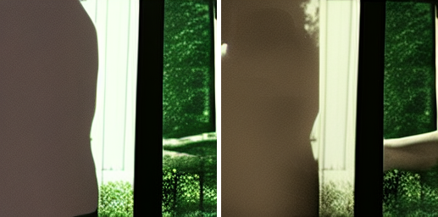

Attention[:, :, size/3: size*(⅔); 2] = attn_base.max()

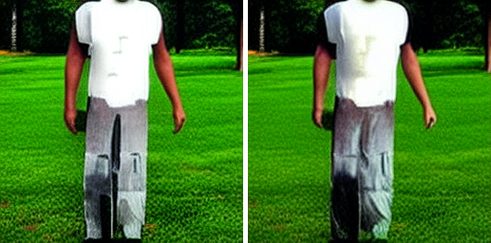

Attn_base[:, :, size*(⅔):size, 2] = attn_base.max()

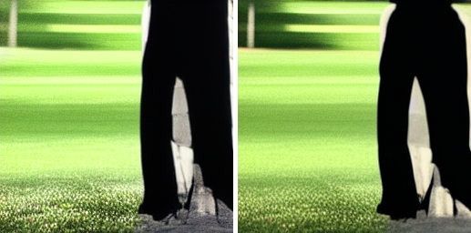

Attn_base[:, :, size/4:size/2, 2] = attn_base.max()

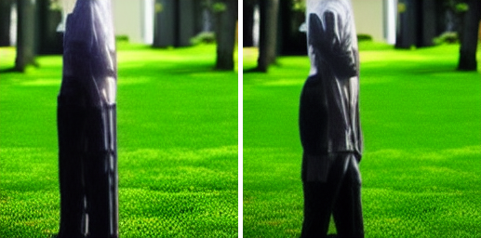

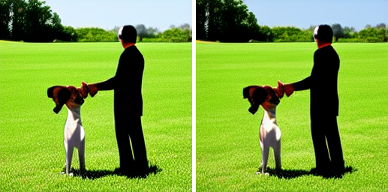

Selecting the dog region

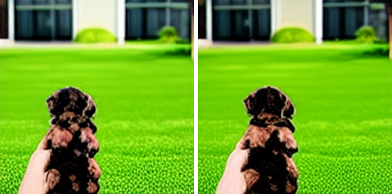

**April 29 Saturday**

Notes on Attend-and-Excite Paper

Generative Semantic Nursing: slightly shifts the latent code at each timestep of the denoising process such that the latent is encouraged to better consider the semantic information passed from the input text prompt.

The attention maps define a probability distribution over the text tokens for each image patch, which determines the dominant tokens in the patch.

An attention map is calculated over linear projections of the intermediate features Q and text embeddings K.

A[i,j,n] denotes the probability assigned to the nth token at the (i,j)-th patch of the intermediate feature map.

Step 1: extracting attention maps

Operate at the 16x16 resolution of feature map, average all 16x16 attention layers and heads

Reweigh attention values by removing from the first <sot> token and apply softmax to the rest of the tokens.

Step 2: obtain smooth attention maps

Apply a gaussian filter to ensure that the attention value of the maximally activated patch is dependent on its neighboring patches. After this operation, each patch is a linear combination of its neighbor patches in the original map.

Step 3: on-the-fly optimization

For each subject token in S, our optimization encourages the existence of at least one patch of Ats with a high activation value.

Loss function L = max(Ls) where Ls = 1 - max(Ats) (s $⊂S$)

Goal is to minimize the loss function L

Demand that each subject token reaches a maximum attention value of at least 0.8.

Step 4: iterative latent refinement

If the attention values of a token do not reach a certain value in the early denoising stages, the corresponding object will not be generated.

Follow-up: while we have not explored applying Attend-and-Excite over a negation (i.e., “not”), this could potentially be achieved by demanding a low attention value for the subject. (Attention-Eraser!)

Ablation Study:

Validate the use of Gaussian Kernels for smoothing the cross attention maps before computing our loss objective. This encourages each patch in the smooth cross attention map to consider its neighboring patches in the original map.

Without Gaussian smoothing, the subject may collapse into a single or small number of patches that only generate partial information.

E.g. in the image below, the attention value in the small area above the rabbit’s head is high but the area is too small to generate the crown. If we apply Gaussian Smoothing so that a larger number of patches have high attention values, then the crown can be successfully generated.

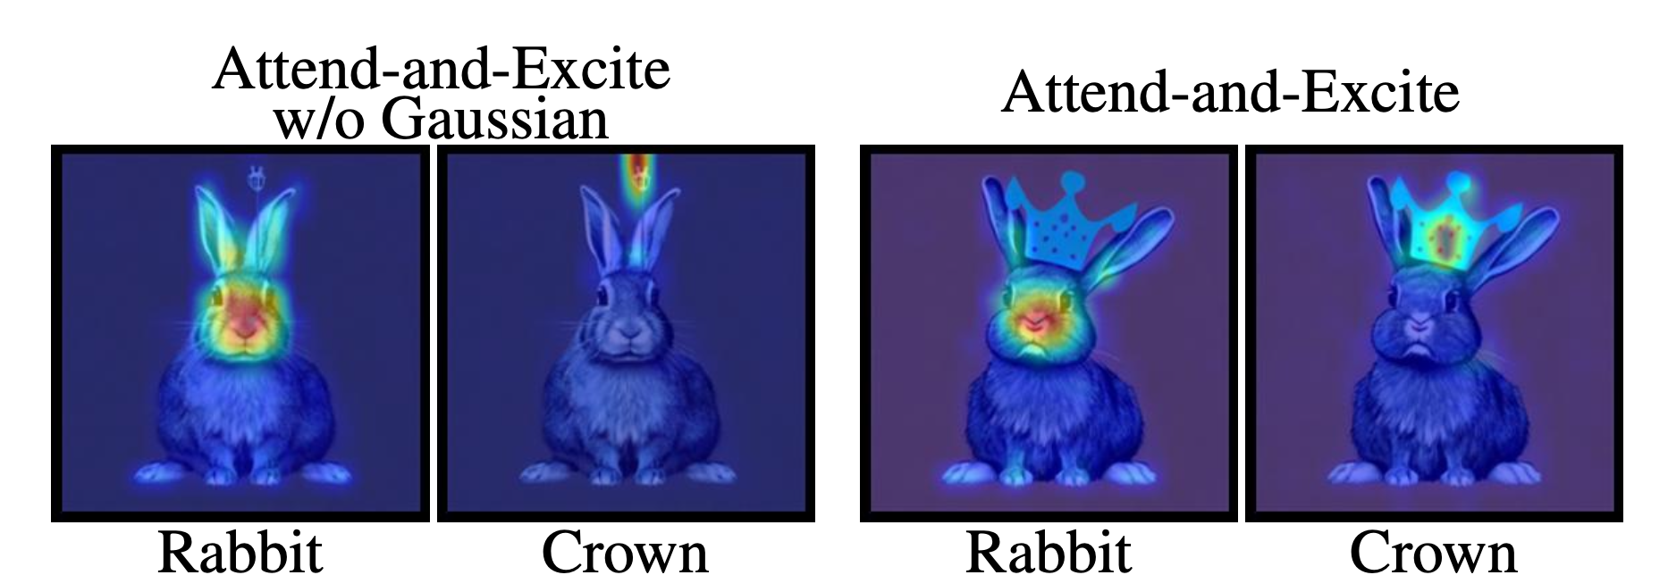

Jax library:

JAX is more flexible than PyTorch and TensorFlow because it allows you to define functions and then automatically compute the derivatives of those functions. This can be useful for training neural networks because you don't have to write the code to compute the derivatives yourself.

@ decorator

An @ symbol at the beginning of a line is used for class and function decorators. A decorator is a design pattern in Python that allows a user to add new functionality to an existing object without modifying its structure. Decorators are usually called before the definition of a function you want to decorate.

To run a local file on jupyter notebook

pip install notebook (already installed in CV research folder)

jupyter notebook

torch.no_grad()

Disabling gradient calculation is useful for inference, when you are sure that you will not call Tensor.backward(). It will reduce memory consumption for computations that would otherwise have requires_grad=True.

Indices to alter: tokens to strengthen the attention value of

Alternative loss objective for attentionEraser

L = sum(token loss) token loss = max(Ats)

Minimize the max attention value of the selected object

prompt = “a book and a pencil” attention-erase ‘book’



A superman and a batman attention-erase ‘batman’

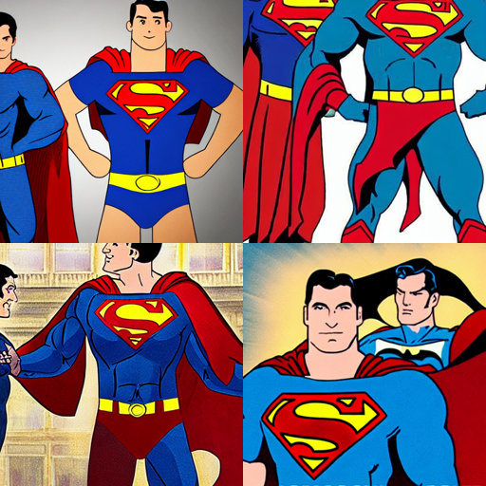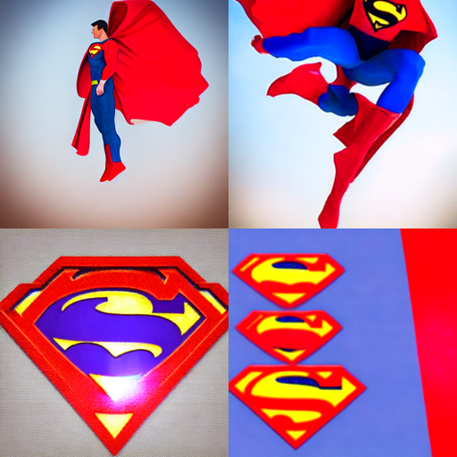

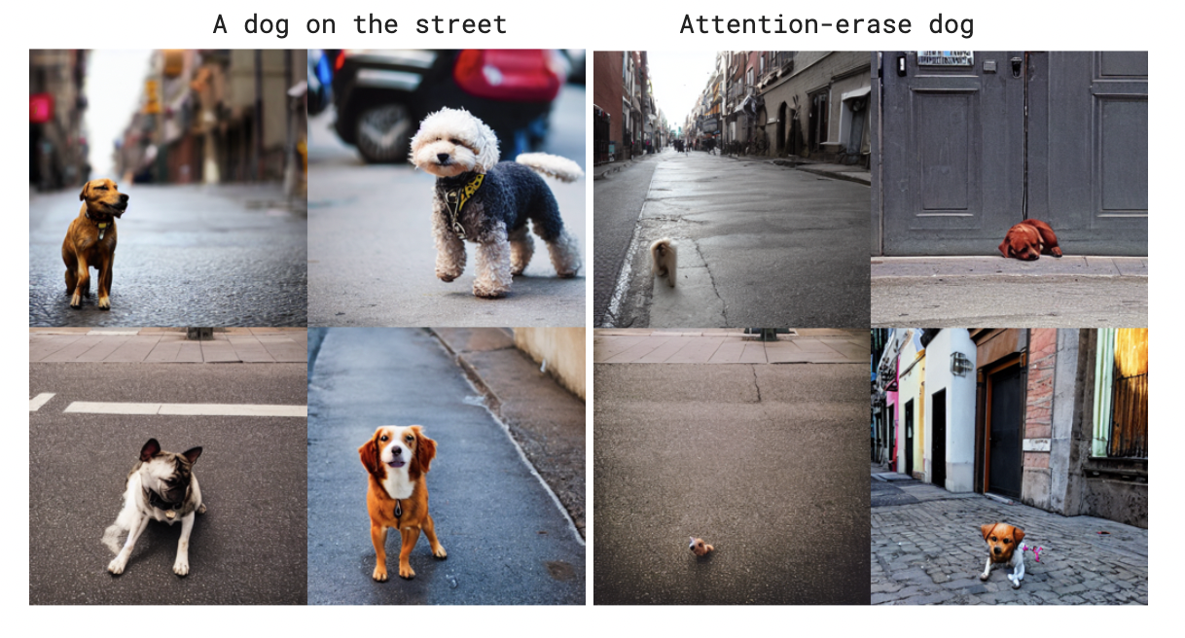

L = sum(token loss) token loss = sum([top 3 largest attention patches values])

Minimize the sum of the top 3 largest attention patches for the selected object

A dog on the street

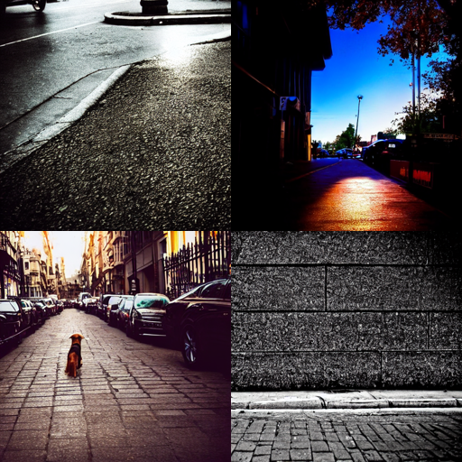

What does the model know about distance from camera and scale?

Prompt engineering changes to prompt, size, distance?

Attention swapping, fine-tune weights (unitune, dreambooth), induce the same control to latents. Compare cost component

May 08:

Research questions to investigate:

In attention-eraser demo:

Evaluate differences between size and proportion

A dog on the street

​​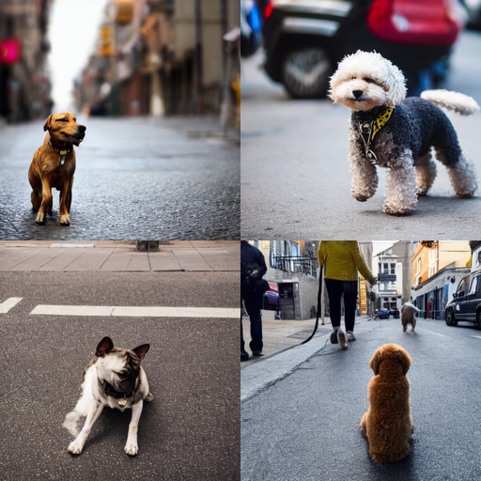

A dog on the street far away

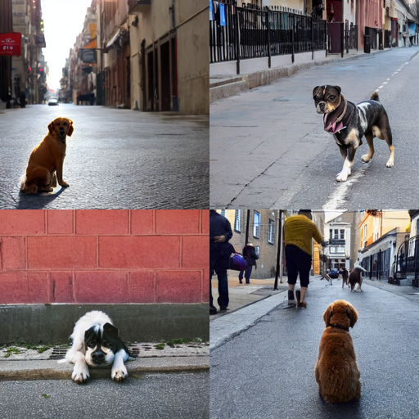

A small dog on the street

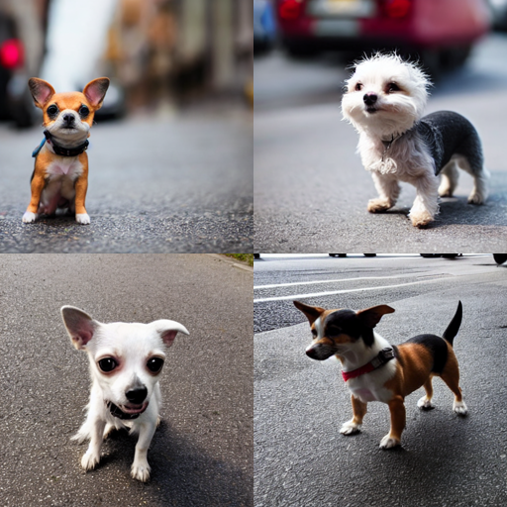

A little dog on the street

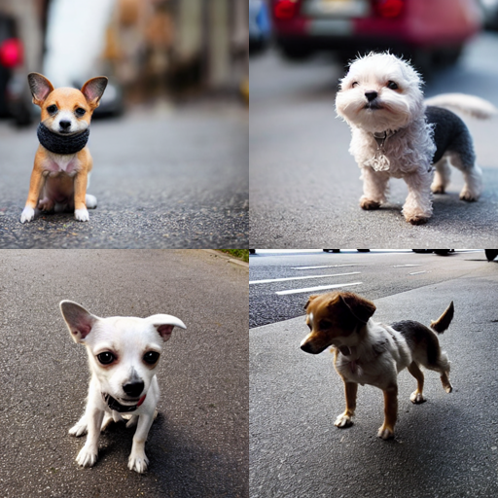

A dog on the street, n = 1

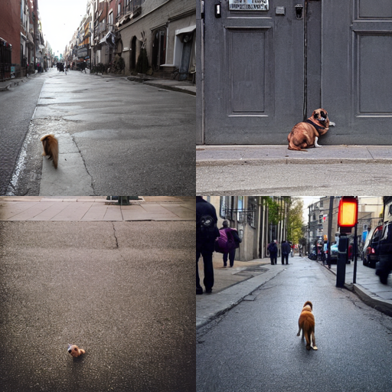

Nudging the latents gradually to produce attention values

Adjusting the attention values of the 16x16 spatial units and see what happens

Removing the max and then redistribute the attention values to others

A man walking down the street

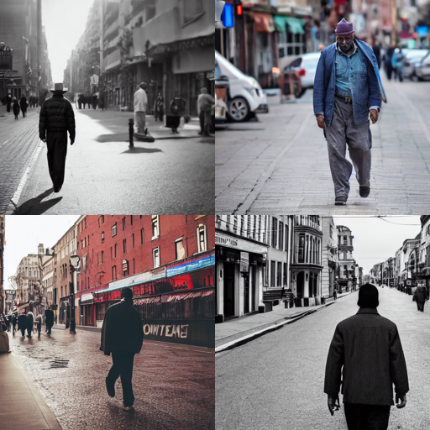

A man walking down the street, n=1

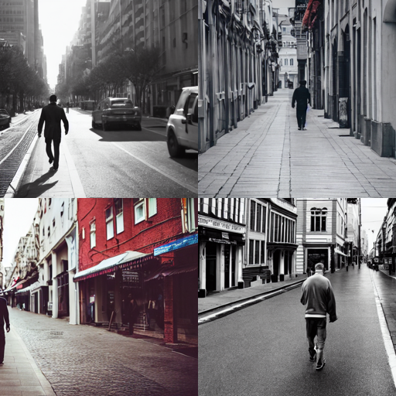

A man walking down the street, n=2

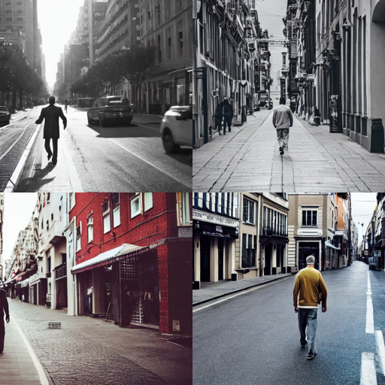

A man walking down the street,n=2

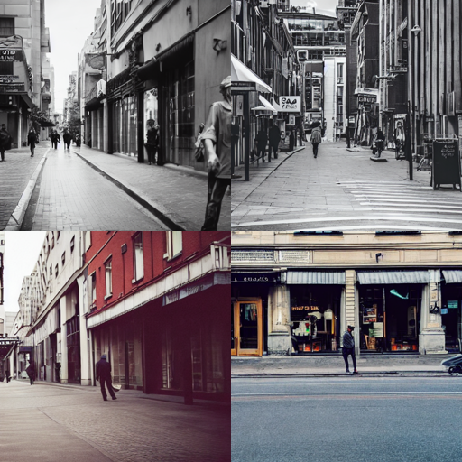

A man walking down the street far away

